Fundamentals of Engineering II (9621)

Technical Design Review

**Eco-Rail System (ERS)**

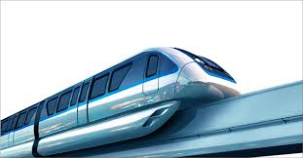

Submitted by:

Team O

Caleb Bucci, Andrew Nguyen, Jason Turschak, Hongda Lin

**Table of Contents**

**+++++++++++++++++++++++++++++++++++++++++++++++++++++++++**

**Technical Design Review Brief OutLine**

**Executive Summary 4-5**

**Problem Definition Review 5-15**

**Conceptual Design Review 15-29**

**Final Design Review 29-35**

**Reference 35-36**

**Appendix 36-55**

**+++++++++++++++++++++++++++++++++++++++++++++++++++++++++**

**Technical Design Review Detail**

**R1 –Problem Definition Review**

**\*Introduction 5-6**

**\*Problem Definition 6-8**

**\*End Users 8-9**

**~Persona**

**~User Need**

**\*Market Character 9-11**

**~Stakeholder**

**~Market Size**

**~Current Alternatives**

**\*Research Results 12-13**

**\*Value Proposition 13-15**

**R2 –Conceptual Design REVIEW**

**\*Brainstorming Full-System Design 15-19**

**~Process description**

**~Brainstorm Result (Put detail in Appendix)**

**~Updated Needs and Ranking**

**~Two Concept Descriptions with Sketches**

**\*Full-System Concept Selection 19-22**

**~Pugh Scoring Matrix**

**~Description and sketch of final selected full-system concept**

**~User feedback on final full-system concept selection**

**\*Full-System Design Requirements 22**

**\*Prototype Concepts 23-26**

**~Prototype Requirements Correlation Matrix**

**~Prototype Design Requirements**

**~Prototype Detail Design**

**\*Verification Plan 26-29**

**Final Design Review**

**\*Prototype Test Results 29-33**

**~Create/ Model Prototypes**

**~Final Prototype Design**

**~Prototype Test Results**

**Conclusions and Recommendations 33-35**

**\*Validation**

**\*Impact**

**\*Project Recommendations**

**References** **35-36**

**Appendix** **35-50**

**Primary Research Methodology**

**Detailed Primary Research Data**

**Persona**

**Brainstorming/Concept Ideas**

**Presentations**

**Team Working Agreement**

**Expected Outcomes 50-55**

**1.Identify Opportunity**

**2.Define a Problem**

**3.Define User Needs**

**4.Investigate the Market**

**5.Create Value Proposition**

**6.Develop Concepts and Models**

**7.Analyze Solutions**

**8.Determine Design Requirements**

**9.Perform Detail Design**

**10.Create Prototypes**

**11.Verify Requirements**

**12.Validate Market (user needs)**

**13.Evaluate Economic Benefits (revenues and expenses)**

**14.Evaluate Societal Benefits**

**15.Produce Effective Communications**

**16.Embody Character**

**Student Learning Objectives: 55**

**+++++++++++++++++++++++++++++++++++++++++++++++++++++++++**

**Executive Summary**

A large majority of the global workforce faces troubles commuting to their jobs, and collectively, hundreds of thousands of hours of potential productivity are wasted sitting in traffic. In an effort to streamline this process, the Electric Rail System (ERS) concept was developed. Conventional methods of travel such as cars are inefficient, slow, and become major sources of pollution in large urban environments. Moreover, cars are one of the leading causes of fatalities in the world. The ERS is targeted to address these issues.

The ERS enables travel for both inter and intra city commuters in a way that is safe, fast, and energy efficient. Although methods of commuting such as bikes and buses also exist as the main competitors, each has drawbacks that the ERS overcomes. Bikes are unable to cover long distances in a timely manner, and are not feasible options during the winter, and buses still have to contend with traffic while running on natural gases, a nonrenewable energy source. The ERS is able to cover long distances, going between cities while also maintaining rail lines within them. The ERS also runs on electricity, with solar panels on the top allowing the batteries to recharge during the day. The ERS is based on a rail-system, meaning traffic is not a factor as well. The major competitors to the ERS system would be Hyperloop and subways. Both aim to expedite travel. While subways have the advantage of being more maneuverable, and the Hyperloop is much faster than the ERS, the cost to maintain and construct the infrastructure for both is much greater than the ERS, leaving the ERS as a cheaper alternative. The assembly of the monorail system is much cheaper than excavating tunnels for a subway or producing the airtight chambers necessary for the Hypreloop to function.

In order to develop the ERS design, multiple phases of design and testing will be performed until the optimal standards for safety, efficiency, and emissions are met. Technical devices such as tilt-sensors will be used to carry out these tests.

**R1--Problem Definition Review**

# Introduction

Theme: Energy and Environment

Task: Commuting to and from work over long distances every day.

An opportunity to reduce the time of one’s commute, their carbon footprint, and their stress in everyday life. This will help those who have a long drive to work, who want to be more eco-friendly, and even those who just don’t want to deal with the stress of driving.

# Problem Definition

## Pains and Gains

Pains:

* Cars cause air pollution which hurts the environment.
* Cars use gas, which is a natural resource that cannot regenerate.
* The more cars that are being driven, the more roads that also need to be built, hence more land that needs to be destroyed to make room for the new roads.
* Commuting long-distance is very expensive and time-consuming.

Gains:

* A new solution can provide me with a faster way to get to work.
* A new solution can give me the potential to travel farther distances in a more convenient manner.
* A new solution can provide me with the ability to use renewable, clean energy sources.
* A new solution can relieve me of unnecessary stress every morning because I won’t have to wake up as early.

## User Experience Chart

| Experience level | Pollution | Faster Commute | Monetary  Expense | Less Stress | Deplete natural resources | Potential to commute farther | Roads take up land | Utilize other renewable energy options |
| --- | --- | --- | --- | --- | --- | --- | --- | --- |
| ++ |  | ++ |  |  |  |  |  | ++ |
| + |  |  |  | + |  | + |  |  |
| O |  |  | O |  |  |  |  |  |
| — |  |  |  |  |  |  | — |  |
| — — | — — |  |  |  | — — |  |  |  |

# End Users

## Persona

## User Needs Chart

| Less Stress | Faster Commute | Environmental |
| --- | --- | --- |
| Cheaper | Time for Hobbies | Modernized |
| Reliability | Ease of Access | Comfortable |
| Safety |  |  |

## Pairwise Comparison Chart

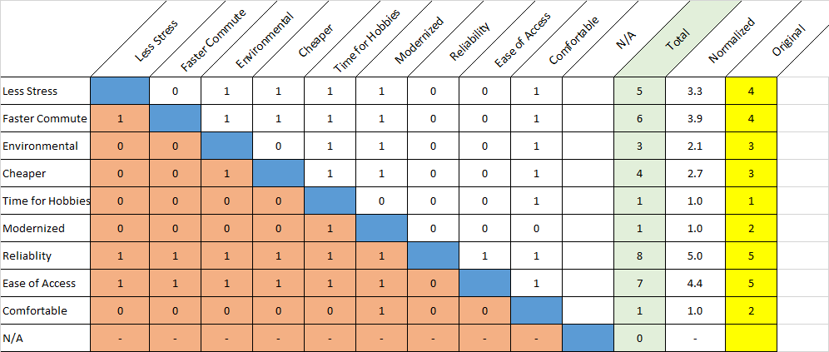

# 

# Market Character

## Stakeholders

Negatively Impacted:

* Gas companies - A new solution will use renewable energy and will not require gas.
* Road services - Roads will not need to be as heavily maintained or built.
* Automobile companies - They will not sell as many cars.
* Ride-hailing services - A new solution will be much faster than these services.

Positively Impacted:

* Renewable energy companies - A new solution will come to use their products to power their idea.
* Companies with many commuters - They will be able to transport all of their commuters with ease.
* Environmental activists - They will be happy with the positive effect on the world that the new solution entails.

## Market Size

* State-wide (Hundreds of thousands, maybe even millions, of people)
* This product could affect a countless number of people every day. Anybody that is sick of commuting to and from work could be in the possible market for this product. Other people who are also in the market are people who really care about the environment and want a greener way to travel or even those who occasionally commute long distances like tourists.

## Current Alternatives

* Subway system
* Bus transportation system
* Public bikes
* Electric scooters
* Electric cars
* Gas cars

## Competitive Matrix

| User Need  (Commuting) | Subway system | Bus transportation system | Public bike | Electric scooters | Electric cars | Gas cars |
| --- | --- | --- | --- | --- | --- | --- |
| Less Stress | ✖ | ✖ | ★ | ★ | ★ | ✖ |
| Faster Commute | ★ | ✖ | ✖ | ✖ | ★ | ★ |
| Environmental | ★ | ★ | ★ | ★ | ★ | ✖ |
| Cheaper | ★ | ★ | ★ | ★ | ✖ | ✖ |
| Time for Hobbies | ✖ | ✖ | ★ | ✖ | ★ | ★ |
| Modernized | ★ | ★ | ✖ | ★ | ★ | ★ |
| Reliability | ★ | ★ | ✖ | ✖ | ★ | ★ |
| Ease of Access | ★ | ★ | ✖ | ★ | ✖ | ★ |
| Comfortable | ✖ | ✖ | ✖ | ✖ | ★ | ★ |
| Safety | ★ | ★ | ✖ | ✖ | ✖ | ✖ |

# Research Results

## Ethical Methodology

Each group member will interview a minimum of two different people each, using the possible questions and following the ethical standards each listed in the appendix. Our target audience consists of people who commute to work or school every day, which includes many students and teachers on campus, and those who may want to be more mindful of the environment.

## Summarized Research Results

A total of eight people were interviewed about their daily commutes and any problems stemming from commuting to work daily. Overall, the general consensus among the eight interviewees was that a cleaner, more streamlined way to get to their destinations was welcomed. Some of the interviewees, like Edgar, said that he thinks he would be much less stressed and drained every day if he didn’t have to commute two hours every day in heavy traffic. He is one of the people that said he would love to have a faster way to commute. Some of our secondary sources show that traffic is one of the highest causes of stress in people, which lines up with some of our interviewees. Our sources also say that driving in a car is 20 times more dangerous than riding a transit, which also lines up with how our interviewees feel. They feel unsafe driving in their car, especially in poor conditions like rain or snow. Although not all of our interviewees would use something purely for its eco-friendliness, they all like the idea of a green solution to commuting which will help the environment. Our research also shows that other energy types, like electricity, are even cheaper on some occasions and are even much more eco-friendly than gas.

# Value Proposition

## Proposition

Many people, such as those who live far from work or those who live in a heavily trafficked area, often share their concerns about commuting to and from work over long distances every day, especially when it comes to car pollution, time consumption and high-stress levels. We are going to create a product to help these people plan their long-distance commuting every day. We will help them reduce their carbon footprint, we will shorten their commute, and we will lower their stress levels. They shouldn’t need to feel stressed when commuting to and from work every day. They will have a more effective and relaxed way of traveling instead. Therefore, we plan to create an electric-powered monorail, which is environmentally friendly, very quiet, travels fast, has a comfortable interior, and is able to take you anywhere which will help our target audience fulfill their needs of a replacement to driving every day. In addition to creating a monorail system, we will also create an electric scooter hub at every stop, so that even if your destination is a little farther from the designated monorail station you can still save time by hopping onto a scooter which will solve our audience’s problems, including the ones that they may not have even thought of such as having a lower chance of vehicle accidents because the monorail is much safer than driving a car.

## Concept Sketches

After coming up with the solution of an electric-powered monorail, each team member brainstormed individually and completed sketches to help the other team members visualize each other’s thoughts. We then met as a group to review and make sense of everyone’s ideas. The team then discussed logistics and came up with the final drawings depicting the major components of the transportation system. Through consistent communication, the team was able to produce very similar sketches and quickly agree on the future of this project. The main focus is on speed, accessibility, and safety. Safety may be the most important necessity and has been added to the project’s user needs chart. It is our main goal to provide users with a safer, faster, low-stress, and eco-friendly way to travel. Concept sketches of this system can be found in the appendix.

## Popularity

Our project will be very well received because many people will benefit from it. Transportation is essential for everyone, especially for long distance travel. So our ERS system will be perfect for people to travel and people are absolutely going to love it.

## Opportunities

Our project will be very well received because many people will benefit from it. Transportation is essential for everyone, especially for long distance travel. So our ERS system will be perfect for people to travel

**Conceptual Design Review**

# Brainstorming Full-System Design

## Process Description

Through repeated testing of key variables such as energy consumption and speed, team O aims to make the ERS as efficient as possible while maintaining a balance of the two factors. Some proposed methods of accomplishing this are focused on aerodynamics, creating ERS designs that move with less air friction, and therefore can move quickly and efficiently. The other being weight, creating a design that is able to sustain a larger traffic volume while still being able to move at an acceptable flow speed. Moreover, reaching the required standards for safety, weather resistance, and stopping precision are all factors that will be tested for.

After discussing within our team as well as with other teams, we have decided, through multiple recommendations and thorough review, that the best course of action towards creating our prototype is to create a design that travels expediently while still maintaining the stability necessary to minimize lateral rocking. In order to achieve this, we hope to gather research determining the most appropriate percentage grade of the slope on the front end of the ERS, as this will help achieve the teams goal of creating an aerodynamic design. We were also recommended to use a 4-way directional tilt sensor to guarantee that the prototype doesn’t rock too far in any direction. However, if it did, it would be recorded and reported back to us so that we could make adjustments to fix it.

## Brainstorming Results

A total of eight people were interviewed about their daily commutes and any problems stemming from commuting to work daily. Overall, the general consensus among the eight interviewees was that a cleaner, more streamlined way to get to their destinations was welcomed. Some of the interviewees, like Edgar, said that he thinks he would be much less stressed and drained every day if he didn’t have to commute two hours every day in heavy traffic. He is one of the people that said he would love to have a faster way to commute. Some of our secondary sources show that traffic is one of the highest causes of stress in people, which lines up with some of our interviewees. Our sources also say that driving in a car is 20 times more dangerous than riding a transit, which also lines up with how our interviewees feel. They feel unsafe driving in their car, especially in poor conditions like rain or snow. Although not all of our interviewees would use something purely for its eco-friendliness, they all like the idea of a green solution to commuting which will help the environment. Our research also shows that other energy types, like electricity, are even cheaper on some occasions and are even much more eco-friendly than gas.

## Updated Needs and Rankings

| Less Stress | Faster Commute | Environmental |
| --- | --- | --- |
| Cheaper | Time for Hobbies | Modernized |
| Reliability | Ease of Access | Comfortable |



## Two Concept Descriptions with Sketches

During the initial conception of the electric-powered monorail, each team member brainstormed individually and completed sketches to help the other team members visualize each other’s thoughts. We then met as a group to review and make sense of everyone’s ideas. The team then discussed logistics and came up with the final drawings depicting the major components of the transportation system. Through consistent communication, the team was able to produce very similar sketches and quickly agree on the future of this project. The main focus is on speed, accessibility, and safety. Safety may be the most important necessity and has been added to the project’s user needs chart. It is our main goal to provide users with a safer, faster, low-stress, and eco-friendly way to travel.

Our final concept for a new form of transportation that will reduce one’s commute time, carbon footprint, and stress, consists of incorporating both the electric monorail and the solar-powered scooters into one system. This Eco-Rail System takes advantage of the best perks that each has to offer to provide the end-user with a much better form of transportation. The ERS is able to bypass the traffic that collects on highways leading into metropolitan areas. Then, when in the city, there will be electric scooters positioned at ERS stops to augment the distance that commuters can travel while on the ERS network of vehicles. This also allows for easier maneuverability through inner city traffic.

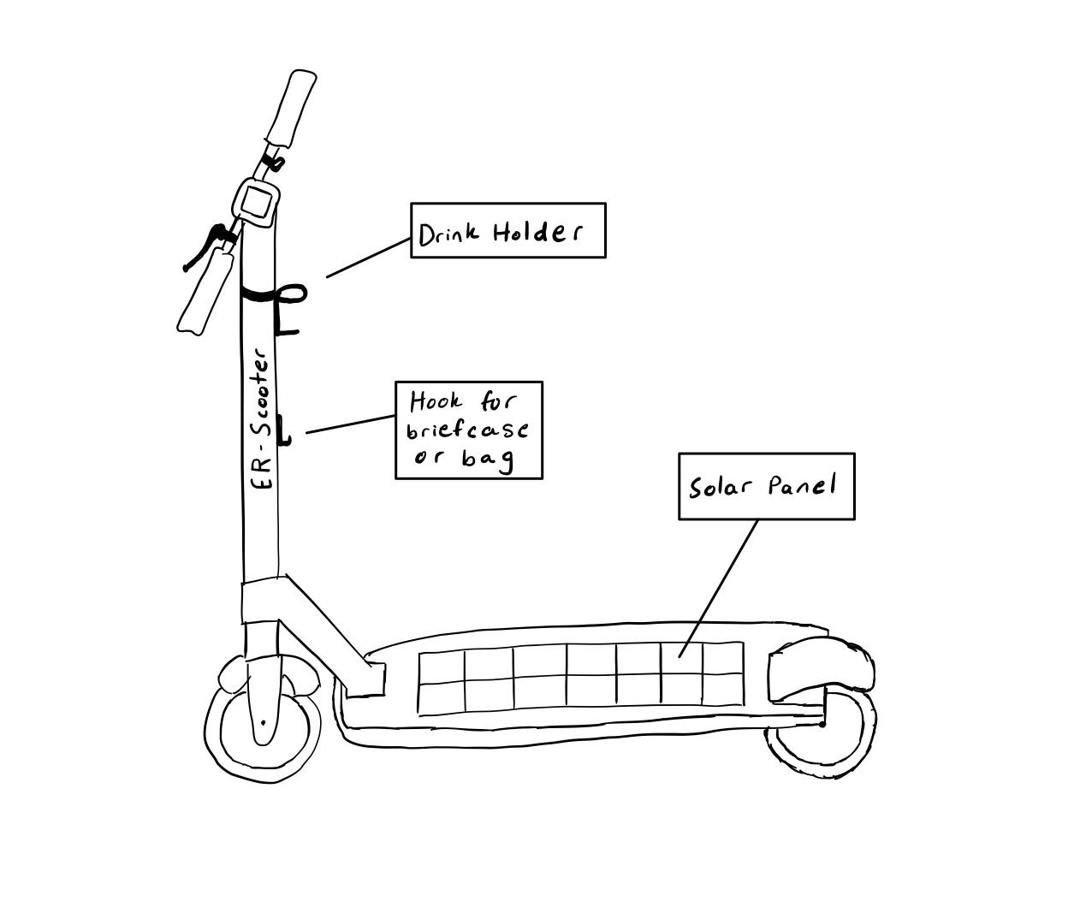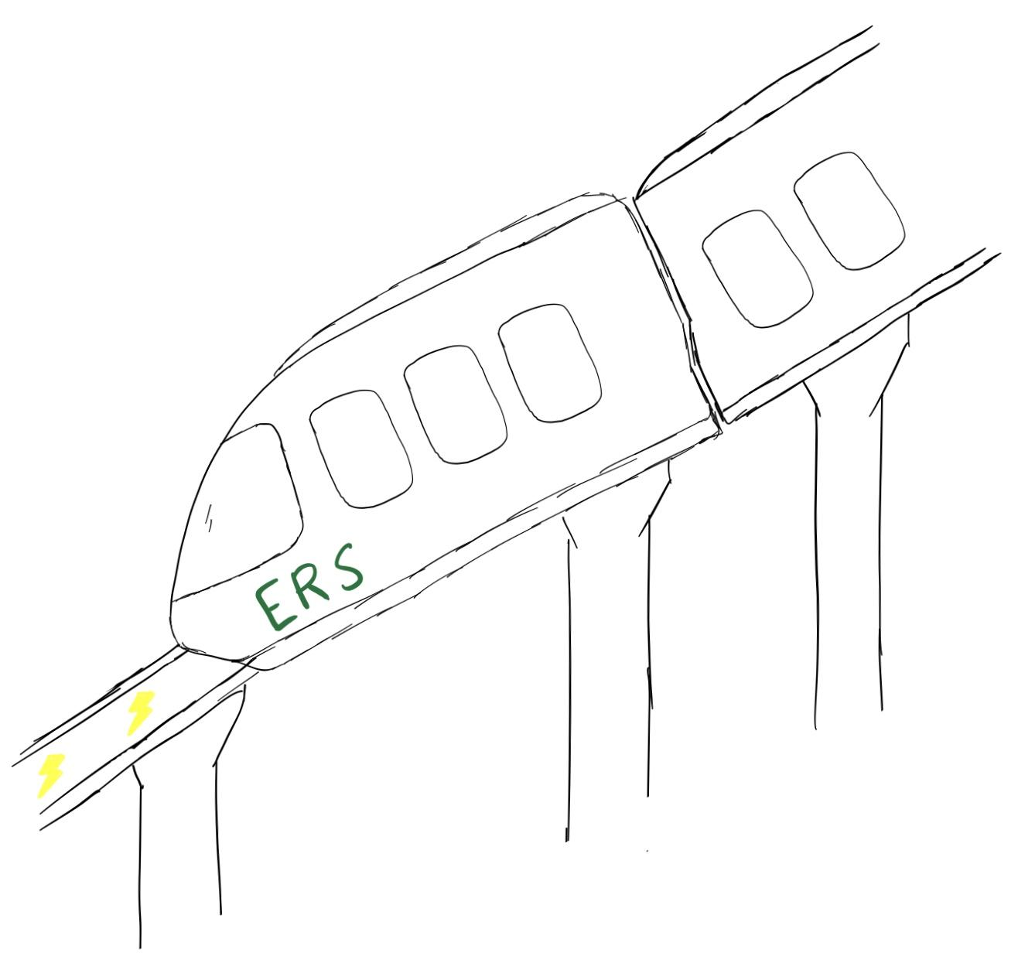

# Full-System Concept Selection

## Pugh Matrix

**Pugh Matrix (Old)**

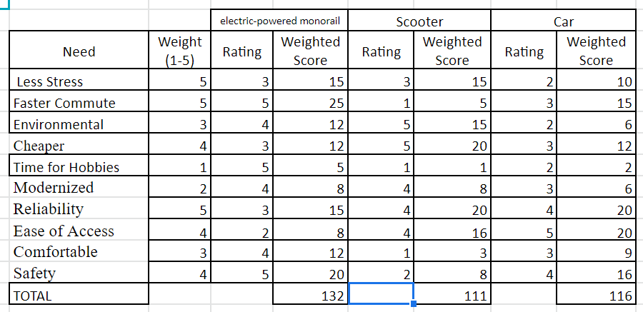

**Pugh Matrix (Updated)**

|  |  | electric-powered monorail | | Scooter | | Car | |
| --- | --- | --- | --- | --- | --- | --- | --- |
| Need | Weight (1-5) | Rating | Weighted Score | Rating | Weighted Score | Rating | Weighted Score |
| Less Stress | 5 | 3 | 15 | 3 | 15 | 2 | 10 |
| Faster Commute | 5 | 5 | 25 | 1 | 5 | 3 | 15 |
| Environmental | 2 | 4 | 8 | 5 | 10 | 2 | 4 |
| Cheaper | 3 | 3 | 9 | 5 | 15 | 3 | 9 |
| Modernized | 2 | 4 | 8 | 4 | 8 | 3 | 6 |
| Reliability | 5 | 3 | 15 | 4 | 20 | 4 | 20 |
| Ease of Access | 4 | 2 | 8 | 4 | 16 | 5 | 20 |
| Comfortable | 4 | 4 | 16 | 1 | 4 | 3 | 12 |
| Safety | 5 | 5 | 25 | 2 | 10 | 4 | 20 |
| TOTAL |  |  | 129 |  | 103 |  | 116 |

## Description and Sketch of Final Selected Full-System Concept

Our final concept for a new form of transportation that will reduce one’s commute time, carbon footprint, and stress, consists of incorporating both the electric monorail and the solar-powered scooters into one system. This Eco-Rail System takes advantage of the best perks that each has to offer in order to provide the end-user with a much better form of transportation. The ERS is able to bypass the traffic that collects on highways leading into metropolitan areas. Then, when in the city, there will be electric scooters positioned at ERS stops to augment the distance that commuters can travel while on the ERS network of vehicles. This also allows for easier maneuverability through inner-city traffic.

## User Feedback on Final Full-System Concept Selection

In our updated pugh scoring matrix, we have found that users care more about things like reliability, safety, and stressfulness of their varying forms of commuting over things like cost, environmental-friendliness, and extra time for hobbies. They also wanted to be more comfortable, because when they are not comfortable they get more stressed, which is the opposite of what they want. They still strongly care about being less stressed and having a faster commute, and they would feel better if the mode of transportation was environmentally friendly, but most said that it wouldn’t affect their decision when using it. Also, after gathering more end-user feedback, we were able to make small changes to our design that helped alleviate any concerns. For instance, the sketch of the scooter design that will be incorporated into our transportation system was updated. It now includes amenities such as a drink holder and a baggage hook for those who thought having their hands full would not allow them to ride the scooters.

# Full-System Design Requirements

| **Requirement** | **Range** | **Ideal** |
| --- | --- | --- |
| Energy Efficiency | ‘Refuels’ 2 times per round trip | ‘Refuels’ 1 time per round trip |
| # of Passengers | > 30 people per stop | > 50 people per stop |
| Fast | > 80 mph | > 100 mph |
| Stable | Turbulence has little effect | Turbulence has no effect |
| Safe | Follow all federal requirements | Safer than federal requirements |
| Lightweight | Little to no strain on track | Does not affect track stability |
| Weather-Resistance | Weather has little effect | Weather does not affect it |
| Loading Time of Passengers | 1-2 minutes | < 1 minute |

These requirements create the mold for the finished system. For example, we are going to create the system so that it is energy-efficient, stable, and lightweight. This will affect what material we use, the shape of the material used, the possible charging method used, etc.

# Prototype Concepts

## Prototype Requirement Correlation Matrix

## Prototype Design Requirements

| **Requirement** | **Range** | **Ideal** |
| --- | --- | --- |
| Energy Use | < 80% of initial run | < 60% of initial run |
| Time to Battery Access | 1 - 10 sec | < 2 sec |
| Stopping Precision | < 6-in | < 2-in |
| Hills | < 50% power | < 40% power |
| Safe | Follow all federal requirements | Safer than federal requirements |
| Lightweight | Little to no strain on track | Does not affect track stability |
| Weather-Resistance | Weather has little effect | Weather does not affect it |
| Loading Time | 1-2 minutes | < 1 minute |

According to the correlation matrix, weather-resistance is the most important requirement. It involves everything, from safety to user stress levels. Unsurprisingly, safety is in second place as following all federal standards makes the user feel safer, more comfortable, and stress-free.

## Prototype Detail Design

In our updated pugh scoring matrix, we have found that users care more about things like reliability, safety, and stressfulness of their varying forms of commuting over things like cost, environmental-friendliness, and extra time for hobbies. They also wanted to be more comfortable, because when they are not comfortable they get more stressed, which is the opposite of what they want. They still strongly care about being less stressed and having a faster commute, and they would feel better if the mode of transportation was environmentally friendly, but most said that it wouldn’t affect their decision when using it. Also, after gathering more end-user feedback, we were able to make small changes to our design that helped alleviate any concerns. For instance, the sketch of the scooter design that will be incorporated into our transportation system was updated. It now includes amenities such as a drink holder and a baggage hook for those who thought having their hands full would not allow them to ride the scooters. The monorail design, however, remains very similar since it is still a viable option for the updated end-user’s needs.



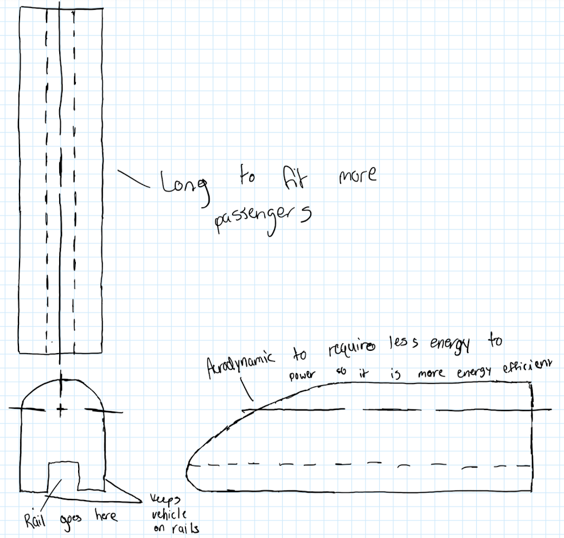

# Verification Plan

The team’s test method will give the necessary results to determine the success of the prototype. Five test runs will be conducted and the average of all of the data gathered will be used. Some of the key requirements that will be tested include speed, stability, and distance traveled. The overall speed of the prototype can be found using the distance and time data that will be gathered. Distance is measured using the reflectance sensors by counting the number of wheel revolutions, and the overall time the program ran can be extracted from the Arduino. Lastly, stability will be measured using a four-directional tilt sensor. This is an important factor to test due to the team's goal to travel at the maximum possible speed. The monorail must maintain an upright position and not tilt while taking a turn.

In order to test the top 3 requirements among end-users, a track in a controlled environment must be created in order to test the prototype in various simulations. The prototype should be able to perform within acceptable standards in various simulated weather conditions, such as rain, hail, wind, and snow. In all weather conditions, the carriage must remain stable and situated firmly on the track while also being able to maintain factors such as brake distance, and energy efficiency to the highest standards.

Moreover, in order to test safety standards, crash tests should be conducted as well as simulated derailments in order to assess the lethality of such accidents. Measuring how the frame reacts upon hard impacts as well as the force a passenger would feel can help to determine the improvements needed to maintain a safe carriage even during the event of an accident.

Furthermore, in order to measure the braking distance of the carriage, high speed cameras should be used upon the initiation of the braking system until total stoppage of the ERS. Multiple tests should be conducted with different rail and brake conditions, and safety features such as an anti-lock braking system should also be tested.

After all of the tests have been completed, the team will use verification scorecards to validate how well the concept design has met the end-users needs. If any needs are not met, the team will continue to work to find ways to fix these shortcomings. An iterative process is used to create a successful prototype and full-system.

**Verification scorecard (Initial)**

| **System Requirement** | **Range** | **Score rubric** | **Score** |
| --- | --- | --- | --- |
| Energy Use | < 80% of initial run | 0%/100% | 10 |
| Time to Battery Access | 1 - 10 sec | -1 pt for each sec. | 10 |
| Stopping Precision | < 6-in | -1 pt for each sec | 10 |
| Hills | < 50% power | 0%/100% | 10 |
| Safe | Follow all federal requirements | 0%/100% | 10 |
| Lightweight | Little to no strain on track | -1 pt for 0.5% strain. | 10 |
| Weather-Resistance | Weather has little effect | -1 pt for 30% weather effect. | 10 |
| Loading Time | 1-2 minutes | -1 pt for each 15 sec. | 10 |
| Requirement 9 | 0% | 0%/0% | 10 |
| Requirement 10 | 0% | 0%/0% | 10 |

**Verification scorecard (Updated)**

| **System Requirement** | **Range** | **Score rubric** | **Score** |
| --- | --- | --- | --- |
| Energy Use | < 80% of initial run | 0%/100% | 11 |
| Time to Battery Access | 1 - 10 sec | -1 pt for each sec. | 11 |
| Stopping Precision | < 6-in | -1 pt for each sec | 12 |
| Hills | < 50% power | 0%/100% | 9 |
| Safe | Follow all federal requirements | 0%/100% | 16 |
| Lightweight | Little to no strain on track | -1 pt for 0.5% strain. | 9 |
| Weather-Resistance | Weather has little effect | -1 pt for 30% weather effect. | 18 |
| Loading Time | 1-2 minutes | -1 pt for each 15 sec. | 12 |
| Requirement 9 | 0% | 0%/0% | 0 |
| Requirement 10 | 0% | 0%/0% | 0 |

**Final Design Review**

**Create/Model Prototypes:**

**Research and Development Methodology:**

Through repeated testing of key variables such as energy consumption and speed, team O aims to make the ERS as efficient as possible while maintaining a balance of the two factors. Some proposed methods of accomplishing this are focused on aerodynamics, creating ERS designs that move with less air friction, and therefore can move quickly and efficiently. The other being weight, creating a design that is able to sustain a larger traffic volume while still being able to move at an acceptable flow speed. Moreover, reaching the required standards for safety, weather resistance, and stopping precision are all factors that will be tested for.

**Takeaways:**

After discussing within our team as well as with other teams, we have decided, through multiple recommendations and thorough review, that the best course of action towards creating our prototype is to create a design that travels very fast and is very stable so that it doesn’t rock back and forth on the tracks. In order to achieve this, we hope to gather research determining the most appropriate percentage grade of the slope on the front end of the ERS, as this will help achieve the teams goal of creating an aerodynamic design. We were also recommended to use a 4-way directional tilt sensor to guarantee that the prototype doesn’t rock too far in any direction. However, if it did, it would be recorded and reported back to us so that we could make adjustments to fix it.

**Research Schedule:**

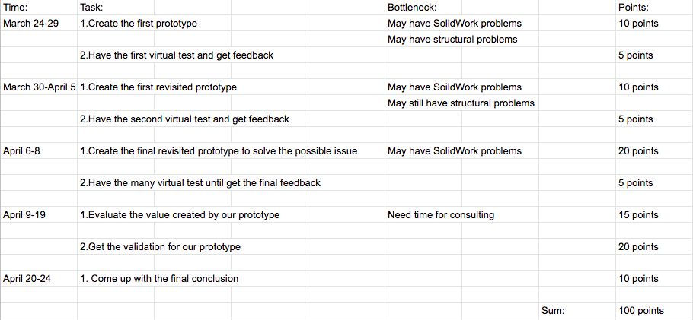

**Final Prototype Design:**

The new revisions made to the teams prototype will all around better meet end-user’s needs. The new aerodynamic shape of the prototype was made to mimic a raindrop. This is due to the fact that a raindrop is the most aerodynamic shape produced in nature. Not only does this new shape allow the ERS to travel at faster speeds, but also allows it to be more energy efficient. These two factors have been of utmost importance to end-users throughout the entirety of the project. Another important change in order to satisfy the end-user need, comfort, was the incorporation of larger windows on the prototype drawing. Larger windows allow the passengers of the monorail to feel less restricted and be able to have a great view of the beautiful outdoors.

Team O thinks it’s prototype drawing is at the completion stage. Our next stage is to build the prototype on SolidWorks. So the only thing that needs to be worried is teamwork. Team O will hold up a meeting on Zoom to discuss how to assign the job and people will start to work very soon.

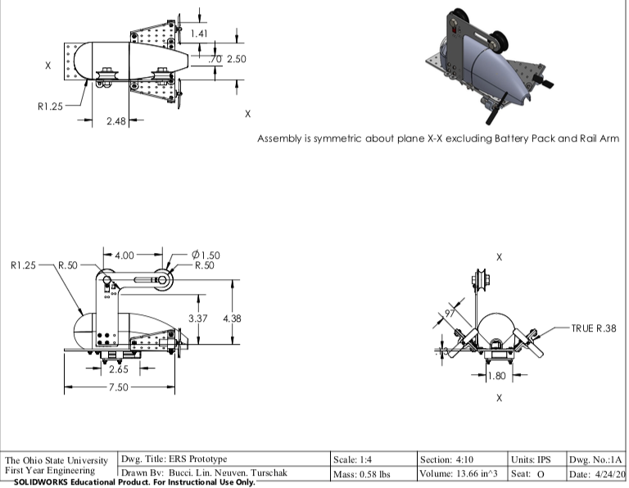

**Prototype Test Results:**

Test Plan:

1.We will test our prototype on the experimental bridge in the classroom and record the speed of the train and the heat it produced. We will also go to the city traffic bureau to collect data and information about the recent train system and its cost. Finally, we will use a questionnaire survey, consult everybody's opinion, and at the same time consult relevant professional personage.

Successful Areas:

1. The Eco-Rail System runs smoothly and quietly which means it succeeded in providing a good rest environment for passengers

2. The monorail itself can go from one place to another very quickly, so that means it is suitable for long-distance travel.

3. The ERS uses electricity as power and also includes solar charging, so it’s absolutely environmentally friendly.

Unsuccessful Areas:

1. The ERS was unsuccessful in the service life of the equipment. Because the speed of the monorail is so fast, it will cause a lot of heat on the wheels and tracks, so our project has extensive maintenance requirements on the tracks and wheels.

2. The ERS was unsuccessful in setting the price of the ticket. According to our estimates, our system needs large maintenance costs and labor costs. It’s impossible to set the price low enough to meet everybody’s requests.

**Conclusions And Recommendations**

**Validation:**

Overall, team O was effective in meeting the highest priority user needs. Areas such as renewable energy, timeliness of travel, and comfort were all successful in tests. However, backend priorities such as cost effectiveness and longevity of equipment could be improved.

Our purpose is to serve all those who need to use our Eco-Rail System, so it is key to consider all aspects that factor into the overall cost in order to keep ticket prices at a minimum. By using equipment and materials that last longer, less money needs to be expended for repair costs and ticket prices can be reduced as a result. It is also important to note that through research our team has concluded that when more track is constructed, the overall price of construction can be reduced. Relatively, it is much cheaper to produce a system that extends over a long distance and has fewer stations, than it is to construct a system with more stations over short distances such as a subway.

**Impact:**

1. **Economic Costs and Impact**

Many expenditures go into the installation and maintenance of an ERS monorail. These would include the salaries of the workers who would build and assemble the ERS as well as land grants to build and operate in an urban environment. There are also monthly operation costs: electricity to run the rail system and employees who staff the ERS such as railroad conductors, security guards, sanitation workers, or any other necessary jobs. Finally, the materials used to build the monorail will also have to be paid for. These are parts of our system that are defined as start-up costs.

Besides expenditures, however, there are also many potential forms of revenue from the Eco-Rail System. Passengers who ride the monorail will be a major source of income. Our systems would be installed in urban, population dense areas where advertising spaces on the outside and inside of the monorail would have a great amount of exposure. These advertisement slots would be valuable real estate for companies looking to place ads due to the large flow of traffic that goes through the ERS. There will be an app for scooter and commuters can just scan the QR code and pay for the ride. Moreover, there will be VIP rooms for people who need a private environment and complete noise isolation. Our train will also have solar power and kinetic power, and we can sell the surplus electricity to the government while still having enough self-generated electricity.

1. **Social Impact**

The main goal of the team’s Eco-Rail System is to provide people with a safer, cleaner, and faster way of transportation. The adoption of ERS systems will reduce the number of accidents on congested highways and eliminate operation and parking costs for drivers who switch to the monorail. Being a fully electric system, the ERS will also reduce harmful carbon emissions. Focus is also placed on long commutes. The ERS will not be used as a means of transportation across the town, but rather from major city to major city. This allows people to make extensive daily commutes more feasible. This also opens up the possibility that people who continue to travel by car for shorter commutes will see reductions in traffic, and arrive at their destination much quicker. Furthermore, it becomes possible for the average consumer to visit and return from a destination hours away all in the same day. People would no longer be limited to the dining and shopping possibilities immediately around them.

**Project Recommendations:**

Our ERS system is widely available to the general public, so it must have priority over other private products in terms of recommendation. At the same time, our ERS system serves the public and guarantees the travel of the public, so our ERS system must be highly recommended.

**References**

[1] Schaefer, Annette. “Commuting Takes Its Toll.” *Scientific American*, Scientific American, 1 Oct. 2005, [www.scientificamerican.com/article/commuting-takes-its-toll/](http://www.scientificamerican.com/article/commuting-takes-its-toll/).

[2] “Transportation-As-A-Service: The Future Of Smart Commuting.” *CB Insights Research*, 6 Apr. 2018, [www.cbinsights.com/research/transportation-service-smart-commuting/](http://www.cbinsights.com/research/transportation-service-smart-commuting/).

[3] “Riding Transit Takes Almost Twice as Long as Driving.” *Governing*, [www.governing.com/topics/transportation-infrastructure/gov-transit-driving-times.html](http://www.governing.com/topics/transportation-infrastructure/gov-transit-driving-times.html).

[4] Shelly, Jared. “How Long Is Too Long to Commute? Here's What Experts Recommend.” *Convene*, Modern Office Spaces, Meeting Spaces, and Event Venues | Convene, 26 Sept. 2018, [convene.com/catalyst/long-commute/.](https://convene.com/catalyst/long-commute/)

[5] Co, About Renewable Resources. “Air Pollution Causes, Effects & Solutions: The Definitive Resource.” *Renewable Resources Coalition*, 15 July 2019, [www.renewableresourcescoalition.org/air-pollution-causes-effects-solutions/](http://www.renewableresourcescoalition.org/air-pollution-causes-effects-solutions/).

[6] “Electric Vehicle Benefits.” *Energy.gov*, www.energy.gov/eere/electricvehicles/electric-vehicle-benefits.

[7] Legrain, Alexander, et al. “Am Stressed, Must Travel: The Relationship between Mode Choice and Commuting Stress.” *Transportation Research Part F: Traffic Psychology and Behaviour*, Pergamon, 10 Sept. 2015, [www.sciencedirect.com/science/article/pii/S1369847815001370](http://www.sciencedirect.com/science/article/pii/S1369847815001370).

[8] Schmitt, Angie, et al. “Here's How Much Safer Transit Is Compared to Driving.” *Streetsblog USA*, 19 Dec. 2014, usa.streetsblog.org/2014/12/19/heres-how-much-safer-transit-is-compared-to-driving/.

# **Appendix**

## Primary Research Methodology

Possible Interview Questions:

* What does your daily routine look like?
* What part of your day do you feel the most stressed?
* Do you feel like you never have enough time in your day?
* Do you think air pollution is having a negative effect on your health?
* Do you think air pollution is one of the reasons that you are stressed?
* If someone came up to you and offered you a way to optimize your time in your daily routine which would save you multiple hours a week, how would you respond?
* What if I could give you a way to reduce your carbon footprint and your costs of commuting daily?

Ethical Standards:

* Politely ask permission to interview someone.
* Inform the interviewee that only their first name will be used in documentation.
* Request to record audio, and assure the interviewee that no visuals will be recorded. However, if visuals are recorded, the individual's face is not shown.
* Let the interviewee know that they do not have to answer any questions that make them uncomfortable.
* Allow the interviewee to opt-out of the interview at any time.
* Be respectful of the interviewee’s opinions during the entire interview.
* Avoid asking personal questions that are not necessary for the interview.
* When finished, thank the person for their time.

## Detailed Primary Research Data

Primary Research:

We found our interviewees by looking for people who traveled either to work or to campus and who would benefit most from something that cuts down on commute times.

**Grace** (4th year CSE Major) - This person is a math tutor. This person was assured that her last name would not be used, her image would not be used, all questions would be respectful, and that she could opt-out at any time.

* Grace is a 4th year CSE major who commutes to school daily. She feels most stressed at the end of the day if she does not get everything on her agenda done. She also does not think that pollution from cars is affecting her health, nor does she think that air pollution is one of the reasons why she is stressed. She would gladly accept help if someone offered her a way to optimize her time to save multiple hours in her week, though she would be skeptical, and she would love a way to reduce her carbon footprint and cost of commuting.

**Chris** (2nd year Security Intelligence Major) - This person is in the NROTC unit and lives off campus on High St. This person was assured that his last name would not be used, his image would not be used, all questions would be respectful, and that he could opt-out at any time.

* Chris is a 2nd year college student majoring in Security Intelligence. He feels most stressed when he is doing NROTC work such as uniform inspections. Moreover, he does not think that the pollution from cars is affecting his health or his stress levels. However, he would gladly accept a way to optimize his time to save multiple hours in his week, and he would also love to reduce his carbon footprint.

**Edgar** - He is an engineer and teacher at Ohio State University who drove to Chicago for two hours every day. This person was assured that his last name would not be used, his image would not be used, all questions would be respectful, and that he could opt-out at any time.

* Edgar would wake up at 4:30 am in order to be ready to leave by 5:00 am so that he could make it to work in Chicago by 7:00 am. By the time he got to work, he would be really tired, and as soon as he feels recharged in the afternoon he then has to get ready to drive back home for another two hours, and he would be absolutely exhausted.
* He would worry about accidents on the road, even though he’s never been in one, and he would be even more stressed out when he had to deal with the weather. He would end up paying about $8 per day because of tolls, and that doesn’t even include the gas prices. He would consider using an electric vehicle if it could cover the distance he needs and if refueling isn’t an issue. He would love to learn how to save multiple hours of his week so that he can stress less and focus more on the important things.

**Andrea** - She is a CEO at Heartland Behavioral Healthcare who drives one hour to work every single day. This person was assured that her last name would not be used, her image would not be used, all questions would be respectful, and that she could opt-out at any time.

* She would wake up at 5:00 am and get ready so that she could leave and be at work by 8:15 am. She gets stressed out about her drive when she is driving in bad weather, otherwise, she enjoys the drive. In fact, she actually prefers the long drive on her way home from work, so that she can get all of her stress from work out of her system and she can just relax once she gets home. Although she loves the drive, she said that she doesn’t think that she has enough time in her day and would love for a way to give her a few more hours every week, and especially loves the idea of reducing her carbon footprint because she wants to be more eco-friendly.

**Leigh Ann** - She is a teacher and has a 30-minute daily commute. This person was assured that her last name would not be used, her image would not be used, all questions would be respectful, and that she could opt-out at any time.

* Leigh Ann leaves her house in the morning by 7:25 am to ensure she gets to the school by 8 am. Although this commute can take longer than 30 minutes some days, she is unbothered by this. The most stressful part of her day is dealing with behavioral issues from her students and does not believe air pollution plays a role in causing her stress at all. She would gladly accept help optimizing her time in order to save several hours a week. She also thinks it would be very nice if she could reduce her carbon footprint and her costs of commuting daily.

**Lauren** - She is a student, nanny, and STNA. Her commute to nannying is 20 minutes, and to clinicals is 15 minutes. This person was assured that her last name would not be used, her image would not be used, all questions would be respectful, and that she could opt-out at any time.

* Lauren has to commute for both her nannying job and for her clinicals. Nannying is about a 20 minute commute and clinicals are about 15 minutes. The most frustrating part is that distance-wise these commutes should only take about 5 minutes, but it takes substantially longer due to traffic. She doesn’t know if air pollution has had a negative effect on her health, and she doesn’t stress about air pollution too much. She would be excited to learn more about how to optimize her schedule and save multiple hours a week. She would also be down for any solution to reduce her carbon footprint so that in the future her kids would be able to see polar bears.

**Tianze** (1st year Math major)--This person is my roommate. This person was assured that his last name would not be used, his image would not be used, all questions would be respectful, and that he could opt-out at any time.

* Tianze is a first-year Math major who gets up early at 6:00 am so he could study at the library. He feels stressed when he could not follow his daily schedule. He believes that car pollution is bad for the environment and he promotes green travel. He doesn’t really want others to help him but he is glad to know that. And he said he likes biking so he would buy a bike as a commuting tool next semester.

**Jiayuan** (1st year CSE major)--This person is my roommate. This person was assured that his last name would not be used, his image would not be used, all questions would be respectful, and that he could opt-out at any time.

* Jiayuan is a first-year CSE major who doesn’t like to get up early. He likes to sleep so the thing that makes him stressed is not sleeping enough. He doesn’t believe that air pollution will affect his health or his stress level. One thing he does care about is the noise. He doesn’t like the sound of heavy traffic. He would like other people to help him to optimize his time. And he thinks the electric car will be the best commuting tool for him in the future.

Secondary Research:

1. This source describes the negative impact that daily commuting has on one’s health.
2. This source describes the possible benefits that public transportation has over the regular commute.
3. This source breaks down why riding transit takes almost twice as long as driving.
4. This source analyzes the average commute and the toll a lengthy commute takes on your mental state.
5. Air pollution can cause immediate and long term effects on human health. It can cause allergies, disease, and even death [5]. Air pollution has a negative effect on health, and cars cause a lot of pollution right now.
6. Electric vehicles are a way to help the environment. They can reduce emissions and even save you money [6], which can actually help you stress out much less in life and be happier overall while also reducing your carbon footprint on the world.
7. Stress has a very negative effect on human life, and one major cause of stress is commuting. Studies show that driving is one of the most stressful forms of transportation [7].
8. Public transportation is much safer than driving yourself. In fact, riding an intercity rail is 20 times safer than driving in a car [8].

## Persona

## 

## Brainstorming/Concept Ideas

Initial Sketches: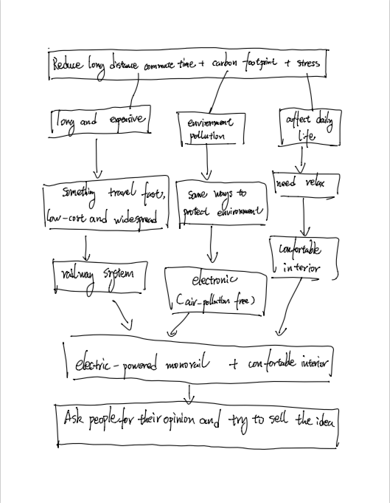

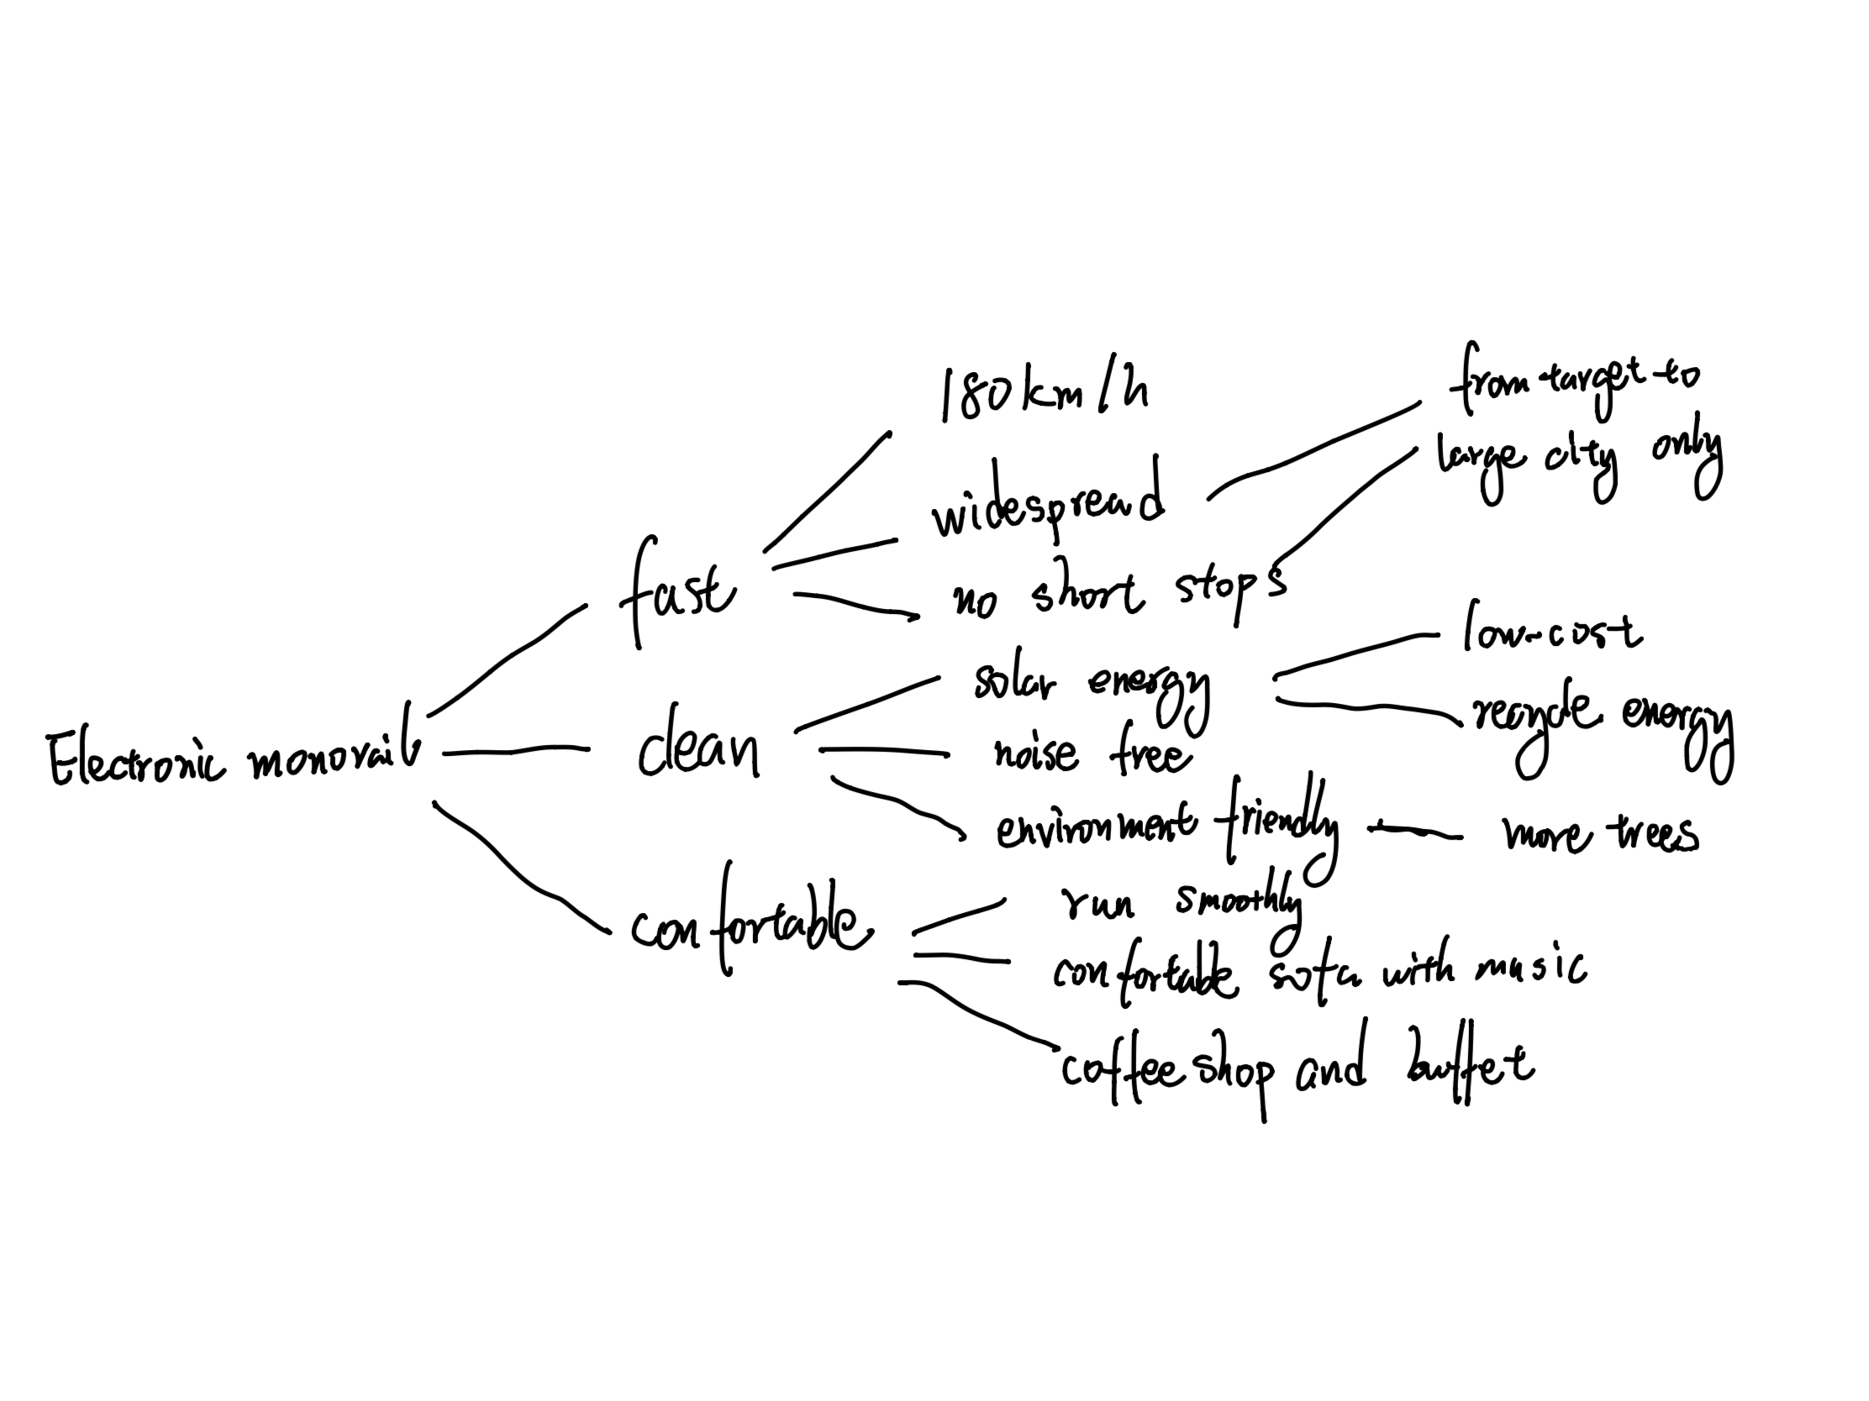

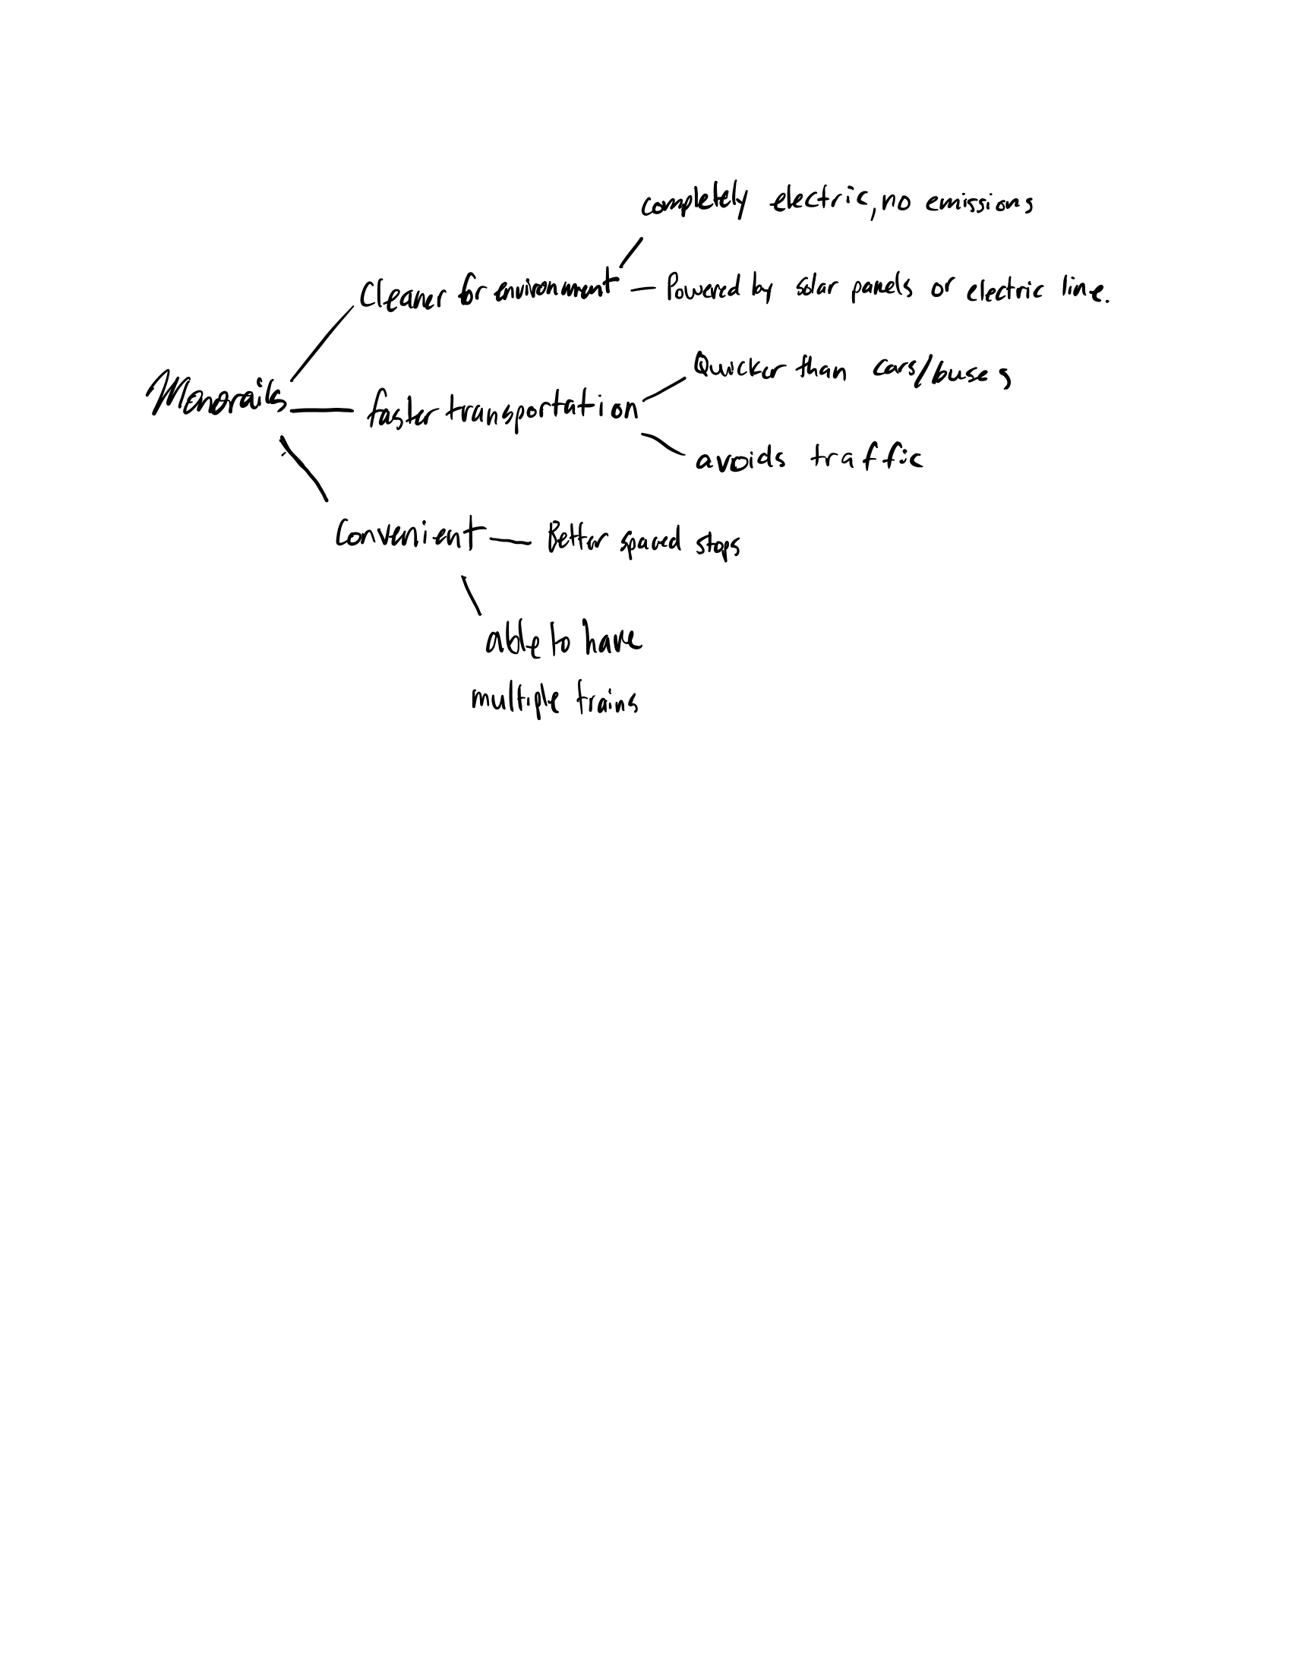

Final Sketches:

 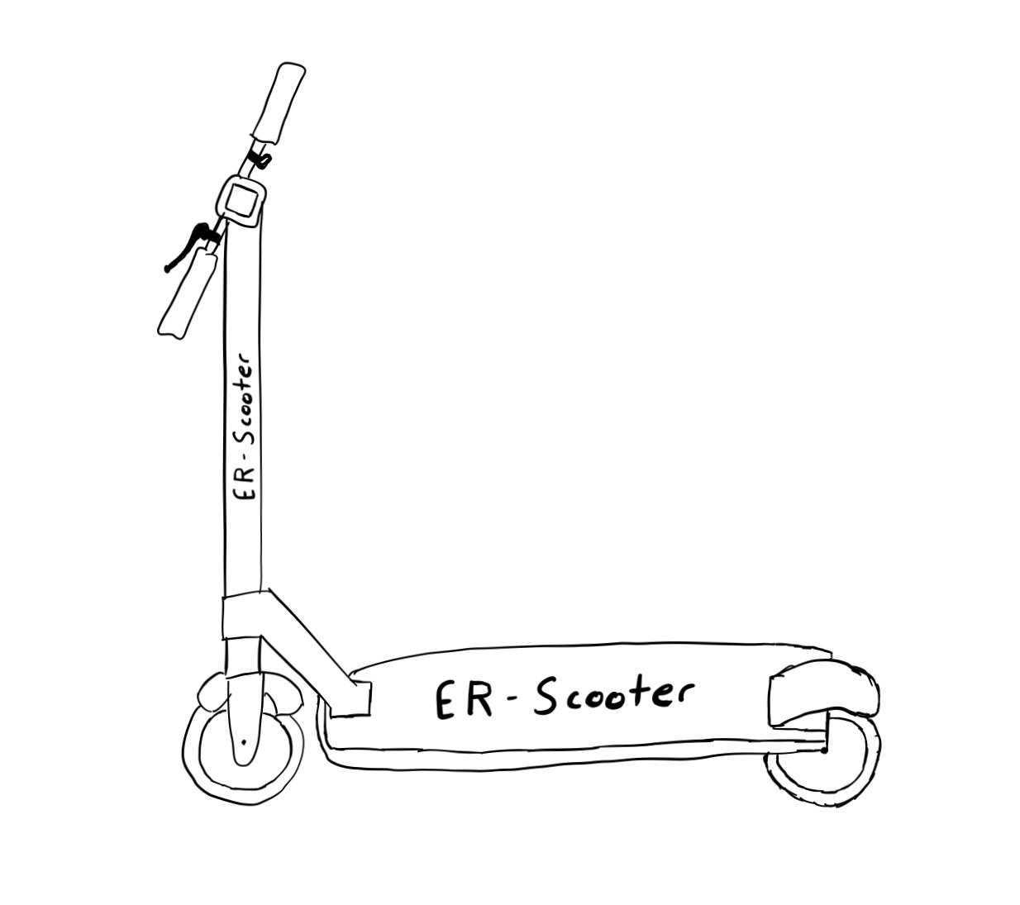

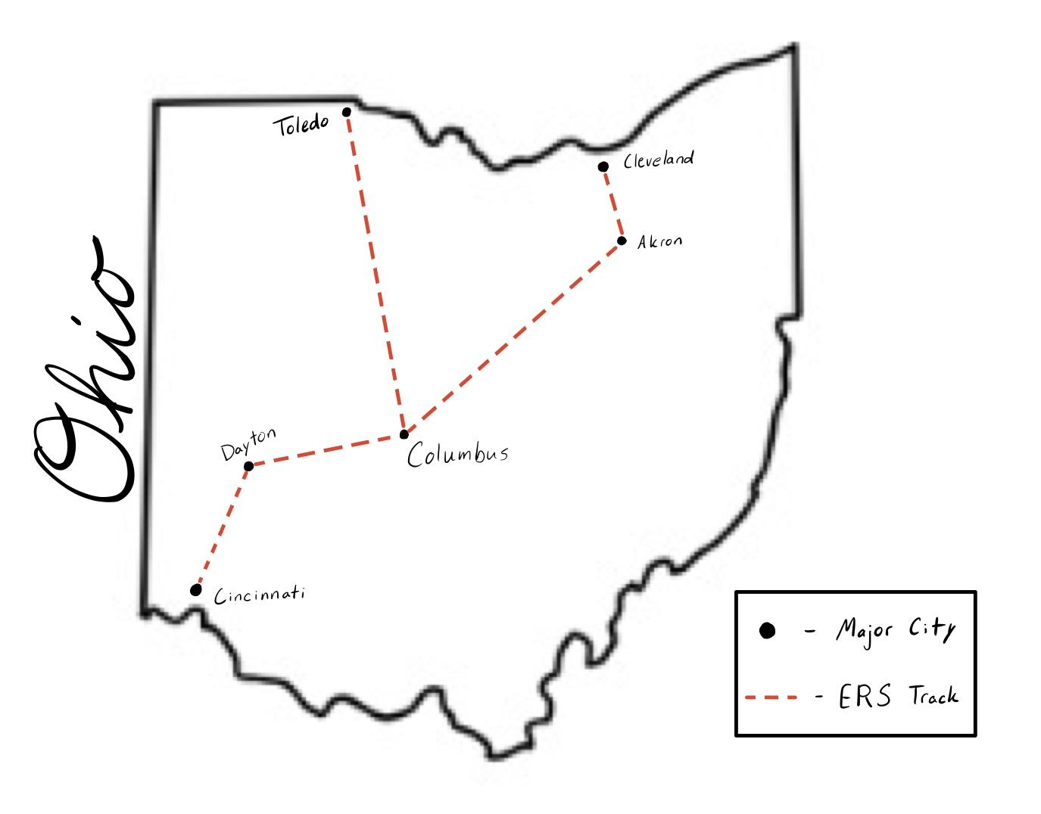



## ERS Isometric



## Presentations

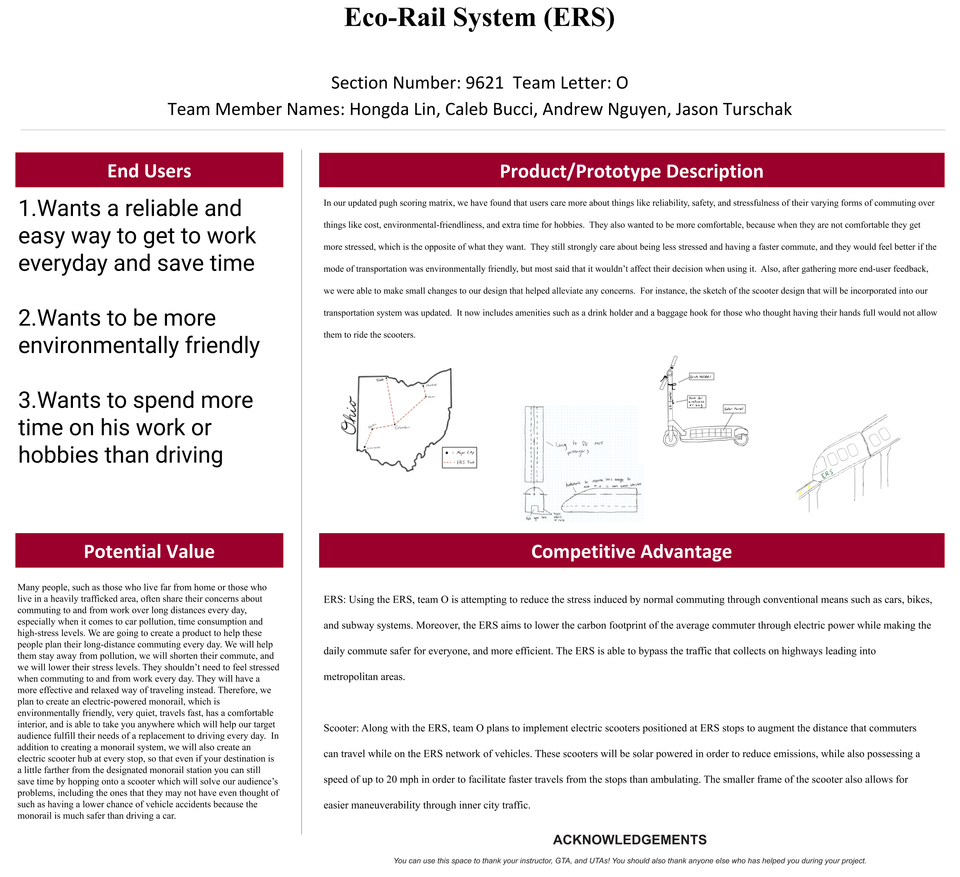

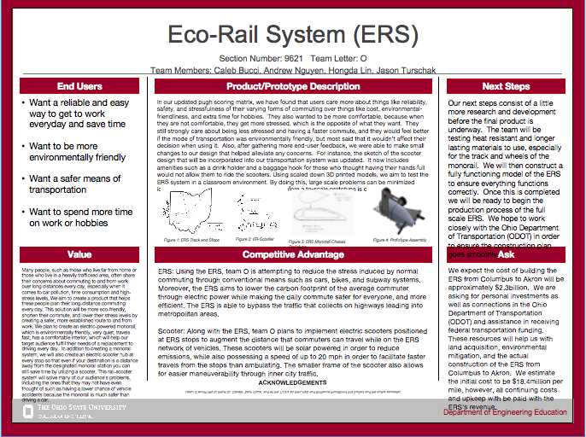

## Team Working Agreement

## 

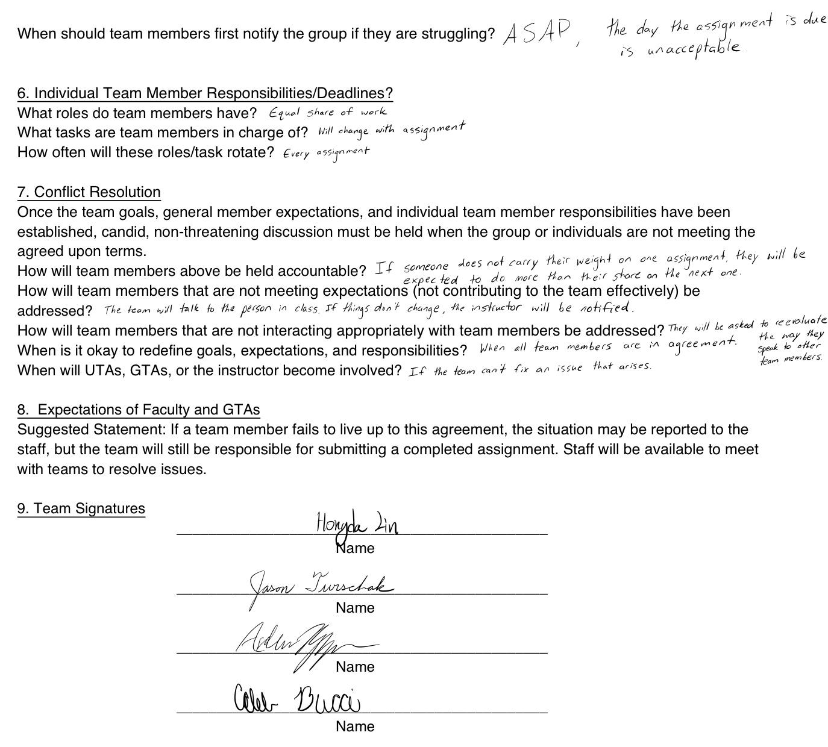

# **Expected Outcomes:**

**1.Identify Opportunity:**

Our ERS system has great opportunities. It can bring us considerable benefits, at the same time as a means of transportation, while convenient for the public and promote themselves.

**2.Define a Problem**

The major issue of our ERS system is the maintenance. Because the speed of the monorail is so fast, it will cause a lot of heat on the wheels and tracks, so our project has extensive maintenance requirements on the tracks and wheels.

**3.Define User Needs**

People use our ERS system for long, quiet, comfortable journeys. So what we need to do is to provide them with a comfortable and fast transportation service.

**4.Investigate the Market**

Our ERS system has a broad market prospect. Firstly, long-distance transportation is a daily necessity for people to travel. Secondly, our system covers a wide area and benefits a large number of people. Our ERS system is most advantageous at a time when long-haul travel solutions are missing from the market.

**5.Create Value Proposition**

People who take our ERS system for long distance traveling will not feel stressed and tired. They will have a quiet and comfortable place to relax and the commuting time will be short. Also, our ERS system uses electricity so it’s environmentally friendly.

**6.Develop Concepts and Models**

The main focus is on speed, accessibility, and safety. Safety may be the most important necessity and has been added to the project’s user needs chart. It is our main goal to provide users with a safer, faster, low-stress, and eco-friendly way to travel.

**7.Analyze Solutions**

The solution for our ERS system disadvantage is we will use heat resistant material for the wheels and roads, so it doesn't wear out very much when it gets hot.

**8.Determine Design Requirements**

It involves everything, from safety to user stress levels. And safety is the main reason to make users feel safer, more comfortable, and stress-free.

**9.Perform Detail Design**

We have found that users care more about things like reliability, safety, and stressfulness of their varying forms of commuting over things like cost, environmental-friendliness, and extra time for hobbies. People also wanted to be more comfortable, because when they are not comfortable they get more stressed, which is the opposite of what they want. They still strongly care about being less stressed and having a faster commute, and they would feel better if the mode of transportation was environmentally friendly, but most said that it wouldn’t affect their decision when using it.

**10.Create Prototypes**

After much discussion and research, team O have assigned work to each member, and all team members participated in the design and assembly of the prototype. The assembly process was successful, and the outcome was the way we wanted it to be. The prototype we created will be the best of all.

**11.Verify Requirements**

The team’s test method will give the necessary results to determine the success of the prototype. Five test runs will be conducted and the average of all of the data gathered will be used. Some of the key requirements that will be tested include speed, stability, and distance traveled. The overall speed of the prototype can be found using the distance and time data that will be gathered. Distance is measured using the reflectance sensors by counting the number of wheel revolutions, and the overall time the program ran can be extracted from the Arduino. Lastly, stability will be measured using a four-directional tilt sensor. This is an important factor to test due to the team's goal to travel at the maximum possible speed. The monorail must maintain an upright position and not tilt while taking a turn.

Moreover, in order to test safety standards, crash tests should be conducted as well as simulated derailments in order to assess the lethality of such accidents. Measuring how the frame reacts upon hard impacts as well as the force a passenger would feel can help to determine the improvements needed to maintain a safe carriage even during the event of an accident.

**12.Validate Market (user needs)**

The market which takes our ERS system wants to provide people with quiet, comfortable journeys. And such a system does not yet have a substantial presence on the market. So when our ERS system enters the market, it will be a big success.

**13.Evaluate Economic Benefits (revenues and expenses)**

Many expenditures go into the installation and maintenance of an ERS monorail. These would include the salaries of the workers who would build and assemble the ERS as well as land grants to build and operate in an urban environment. There are also monthly operation costs: electricity to run the rail system and employees who staff the ERS such as railroad conductors, security guards, sanitation workers, or any other necessary jobs. Finally, the materials used to build the monorail will also have to be paid for. These are parts of our system that are defined as start-up costs.

Besides expenditures, however, there are also many potential forms of revenue from the Eco-Rail System. Passengers who ride the monorail will be a major source of income. Our systems would be installed in urban, population dense areas where advertising spaces on the outside and inside of the monorail would have a great amount of exposure. These advertisement slots would be valuable real estate for companies looking to place ads due to the large flow of traffic that goes through the ERS. There will be an app for scooter and commuters can just scan the QR code and pay for the ride. Moreover, there will be VIP rooms for people who need a private environment and complete noise isolation. Our train will also have solar power and kinetic power, and we can sell the surplus electricity to the government while still having enough self-generated electricity.

**14.Evaluate Societal Benefits**

The main goal of the team’s Eco-Rail System is to provide people with a safer, cleaner, and faster way of transportation. The adoption of ERS systems will reduce the number of accidents on congested highways and eliminate operation and parking costs for drivers who switch to the monorail. Being a fully electric system, the ERS will also reduce harmful carbon emissions. Focus is also placed on long commutes. The ERS will not be used as a means of transportation across the town, but rather from major city to major city. This allows people to make extensive daily commutes more feasible. This also opens up the possibility that people who continue to travel by car for shorter commutes will see reductions in traffic, and arrive at their destination much quicker. Furthermore, it becomes possible for the average consumer to visit and return from a destination hours away all in the same day. People would no longer be limited to the dining and shopping possibilities immediately around them.

**15.Produce Effective Communications**

The communications between members in Team O is effective and productive. Everyone is able to share what they think about the ERS system and willing to take charge of everyone's own parts.

**16.Embody Character**

The ERS system is the result of our team. It represents the efforts of all the team members. Everyone has a corresponding contribution in this project, so this project symbolizes the character of everyone in our team.

# **Student Learning Objectives:**

One of the student learning objectives was to learn how to come up with a product that solves a problem. The students were to find an idea for a device that made life easier, and once they came up with what they wanted to make to solve a problem, the next objective was to figure out how to actually create a product to solve a problem. The students’ next objective would be to learn the market, and to figure out who their product would be best for. They also needed to make sure that their product is viable within their market of choice. The students then needed to learn how to adjust their product for whatever the market wants. In the end, the main objective of the entire project was to learn the processes of creating a product, assessing the market, and bringing a product that people will actually want to life.